C-IT Consulting
Tailored Solutions for Catastrophe Risk Management
Table of Contents
Executive Summary 2
Portfolio Analysis and Risk Segmentation 2
Portfolio Composition and Key Loss Patterns 3
Severity and Tail Behaviour by Risk Factor 3
High-Risk Groups 5
Model-Based Segmentation Insights 5
Frequency: Logistic Regression 5
Stress testing(severity): Gamma GLM 6
Risk Segmentation Framework Summary 7
Actionable Recommendations for HELP 8
Immediate Pricing Actions 8
Incentive Designs for Sustainable Construction 8
CAT Risk Landscape in Florida 8
Coverage Expansion Opportunities 10
Risk Management 11
Reinsurance Market in Florida 12
Recommendation 13
Short-Term 13
Medium Term 13
Long Term 14
HELP and Society 14
References 15
Appendix 16
Global trends 16

Executive Summary
As a mid-sized insurer operating a concentrated commercial property portfolio in Florida, there is significant opportunity for to grow HELP’s business while maintaining a healthy risk profile. Florida’s geography and climate result in considerable catastrophe (CAT) risk including windstorms, storm surge, and secondary perils such as fire and flooding. Please note that the word “windstorm” refers to both hurricanes and tropical windstorms in this report. These hazards are intensifying due to climate change, indicating an increasing need for risk mitigation and climate adaptation strategies. In addition, regulatory and reinsurance pressures present challenges for insurers to remain profitable and offer affordable coverage to policyholders. We provide a three-tiered strategy to refine HELP’s understanding of its CAT exposure and risk mitigation, internal risk segmentation, and increase profitability and market share.
An in-depth analysis of HELP’s internal dataset explores the feasibility of future product options including coverage for property contents, additional living expenses (ALE), guest medical, and liability. The analysis reveals that HELP’s current practices underutilize risk segmentation, as provided risk tiers do not align with actual loss behaviour. Our model allows for enhanced segmentation which will lead to an improved understanding of HELP’s exposure and more accurate pricing and capital allocation.
A market analysis reveals additional opportunities for HELP to remain competitive and increase its market share in the current insurance environment. Competitors in Florida’s CAT insurance market already insure property contents under windstorm coverage, indicating that HELP may be underserving its clients with coverage that only extends to physical damage to the building. This analysis also explores risk mitigation strategies and considerations of risk appetite as well as the need for diversification to maintain solvency with the increasing severity of risks across the Florida and the US.

Portfolio Analysis and Risk Segmentation
In this section, we analyze HELP’s synthetic dataset to explore future product options like contents coverage, ALE, liability, and guest medical. We identify key risk drivers and assess the effectiveness of HELP’s existing risk tiering system. Our findings indicate that the current segmentation framework does not reflect the true loss behaviour of the portfolio, resulting in both underpricing of high-risk exposures and potential overpricing of low-risk ones. A refined segmentation model is developed using both frequency and severity analytics to support more accurate pricing, capital allocation, and underwriting decisions.

Portfolio Composition and Key Loss Patterns
Exploratory Data Analysis and modelling indicate that only a subset of variables meaningfully explains loss behaviour: Coverage type, Occupancy (Greek/ Non-Greek), Building Type (On/Off campus), Sprinkler Protection, and Distance. Other demographic-type variables (e.g., GPA, major, gender) show no predictive value and should be excluded from pricing and underwriting considerations.

Severity and Tail Behaviour by Risk Factor
Coverage Type
- Guest Medical produces the most extreme heavy-tailed severity (multiple $50k–$100k+ losses). Liability exhibits moderate tail risk.
- Personal Property (content-like exposure) has minimal tail volatility, suggesting high potential profitability.

Occupancy and Building Characteristics
- Greek housing mirrors high-hazard commercial occupancies (e.g., bars, clubs), with substantially higher large-loss frequency.
- Off-campus experience larger and more frequent severe claims, consistent with older or less supervised structures.
- Lack of sprinkler protection strongly correlates with heavy-tail severity, confirming its role as a critical mitigation feature.
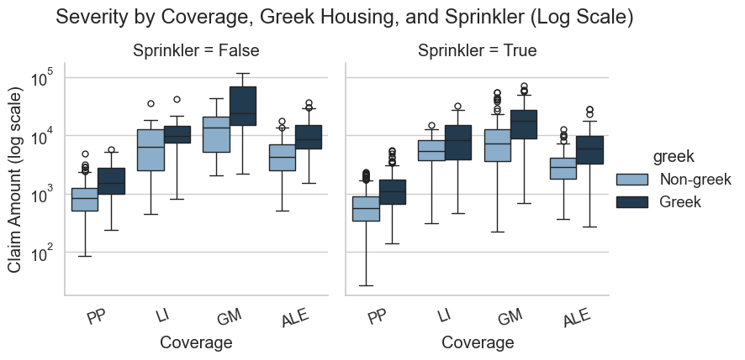

Geographic Indicators
- Claims close to campus show wider severity dispersion and all major outliers, resembling proximity-based CAT hazard patterns (e.g., distance-to-coast in windstorm models).

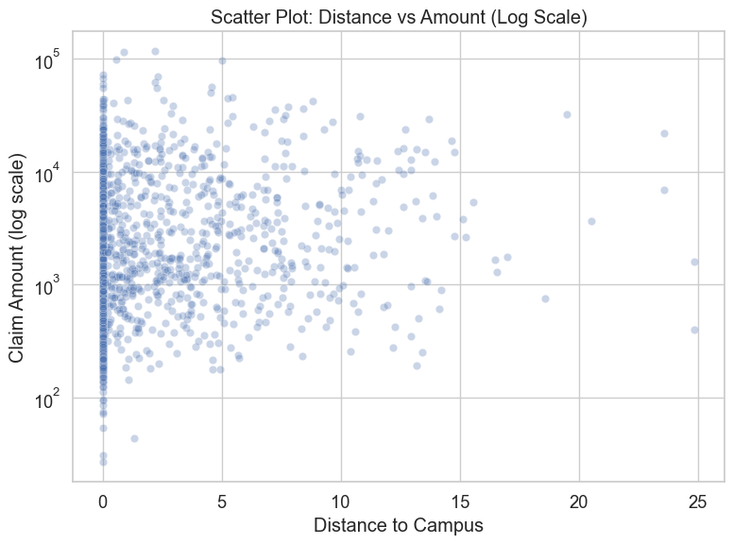

High-Risk Groups
5% tail analysis reveals a distinct high-risk cluster:
Guest Medical × Greek × Off-Campus × No Sprinkler. This is the combination of features that results in the highest concentration of catastrophic severity.
Moderate-risk groups include Greek/off-campus liability exposures.
Personal property (i.e., property contents) exposures form a clear low-risk segment. This indicates that expanding coverage to include contents may be a good option for HELP to meet policyholder needs without taking on an unnecessarily large amount of risk.
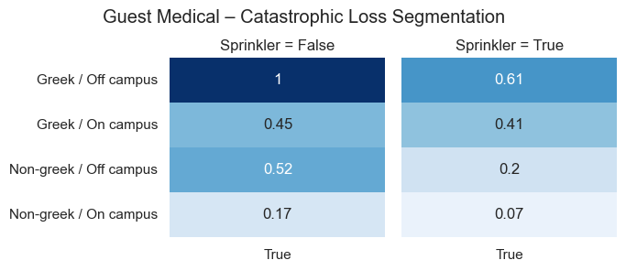

Model-Based Segmentation Insights

Frequency: Logistic Regression
The figure below highlights statistically significant odds ratios across major risk drivers. These ratios measure how the likelihood of experiencing a catastrophic loss changes relative to a baseline category. Guest Medical claims exhibit by far the highest odds of an extreme loss, over 40× the baseline, followed by Liability and Personal Property. Greek housing also carries materially elevated odds, while Off-campus residence and the absence of sprinklers further increase risk.
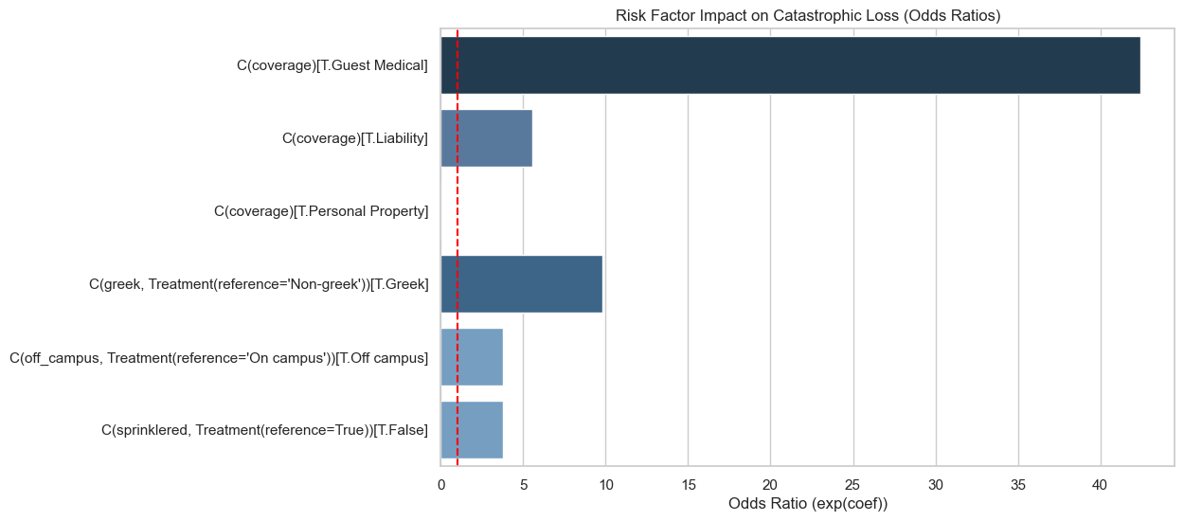
These effects are large and commercially intuitive—ideal for a revised pricing or tiering framework.

Stress testing(severity): Gamma GLM
We assume claim sizes follow a Gamma GLM structure, where expected loss increases exponentially as key risk drivers worsen. Four primary factors—coverage type, Greek housing affiliation, on/off-campus status, and sprinkler protection—are combined to form coherent scenarios that escalate from low to catastrophic risk. Expected losses are evaluated deterministically under each scenario, isolating severity effects while keeping frequency constant.
Expected severity increases sharply across combinations of the four primary drivers of loss. This can be seen in the figure below – the expected loss amount increases linearly when increasing risk from low to high and then has a sharp increase from high to catastrophic risk, as expected.
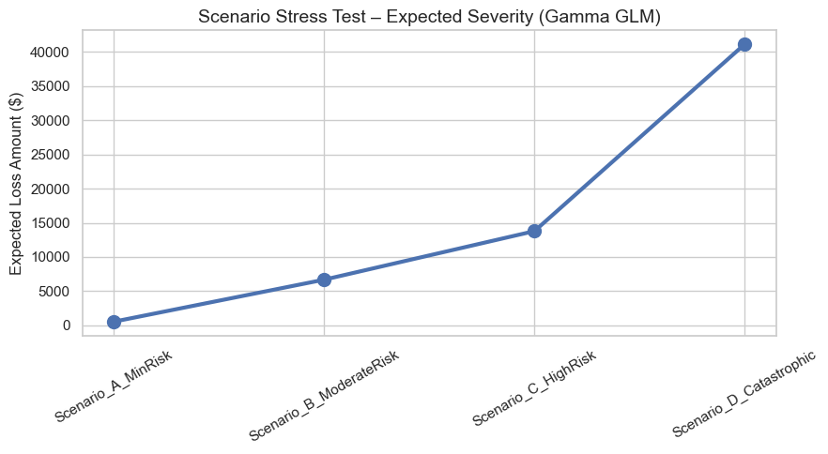

Under stress-test scenarios:
- Scenario A (low risk): $538 expected loss
- Scenario D (catastrophic): $41,124 expected loss
HELP’s existing tiering, however, misclassifies in the table below:
Scenario | Key Risk Factors | Model Tier | HELP Tier
A | PP + Non-greek + On-campus + Sprinkler | 1 | T1: 48% T2: 26% T3: 26%
B | Liability + Non-greek + Off-campus | 1 | T1: 35% T2: 41% T3: 24%
C | Liability + Greek + Off-campus | 2 | T1: 60% T2: 0% T3: 40%
D | Guest Medical + Greek + Off-campus +  No Sprinkler | 3 | T1: 38% T2: 13% T3:50%
This is a structural misalignment that directly leads to mispriced premium and under-reserved capital.

Risk Segmentation Framework Summary
To construct a more accurate and data-driven risk segmentation for HELP, we combine information from both the frequency and severity models. The logistic regression provides the predicted probability of entering the catastrophic tail, while the Gamma GLM supplies the expected loss conditional on a claim occurring. Together, these two components form a unified Risk Score defined as:
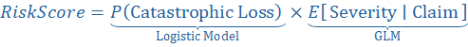
The combined frequency × severity measure represents the pure premium (expected loss), which forms the foundation of a risk-based tiering system. It captures both how likely a high-cost claim is and how large it will be if it occurs. Sorting exposures by this combined Risk Score creates a clear, monotonic risk gradient that aligns strongly with observed catastrophic behavior. This approach ensures that HELP’s segmentation directly reflects the true drivers of tail severity and provides a more reliable foundation for pricing, underwriting, and risk management decisions.

Actionable Recommendations for HELP

Immediate Pricing Actions
- Incorporate sprinkler presence, occupancy type, building type, and coverage type into rating variables.
- Provide premium credits for sprinkler protection and other mitigation features.
- Establish explicit tier relativities based on the Risk Score.

Incentive Designs for Sustainable Construction
According to the National Institute of Building Sciences 2020, every $1 invested in resilient, climate-adaptive building practices saves between $4 and $11 in future disaster losses. This includes upgrades such as reinforced roofing, energy-efficient structural materials, and elevated building systems. These savings directly benefit insurers through reduced claim severity and improved solvency stability.
Incentive Type | Description | Benefit to HELP
Green-building premium credits | 5–10% discount for certified energy-efficient upgrades | Lower claim severity; competitive differentiation
Sustainable repair endorsement | Covers added cost of energy-efficient materials | Encourages resilient rebuilding
Eco-upgrade payout option | Extra payout for choosing sustainable reconstruction | Supports ethical and environmental goals

CAT Risk Landscape in Florida
HELP currently provides property coverage from physical damage caused by hurricanes and tropical windstorms in Florida. Florda’s geographical profile makes it the most hurricane-prone state in the US, posing significant challenges in balancing risk and profitability for Florida based insurers. It has the longest coastline besides Alaska with about two-thirds occupying a peninsula between the Gulf of Mexico and the Atlantic Ocean. No part of its landmass is distant from the ocean, resulting in high exposure to hurricanes and tropical windstorms. In fact, Florida is the only state with exposure to both the Gulf of Mexico and Atlantic Ocean. This configuration allows windstorms to strike from multiple directions, and the warm water contributes to rapid storm intensification. In addition, the flat and low-lying land increases risk for storm surge and other natural disasters like flooding, especially as sea levels rise.
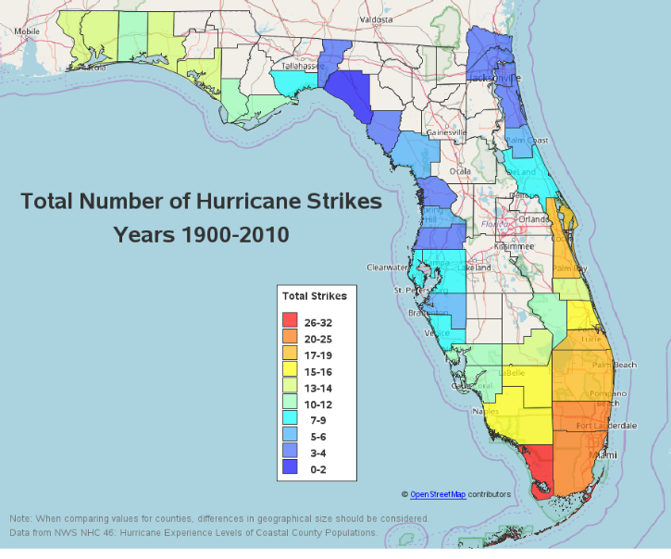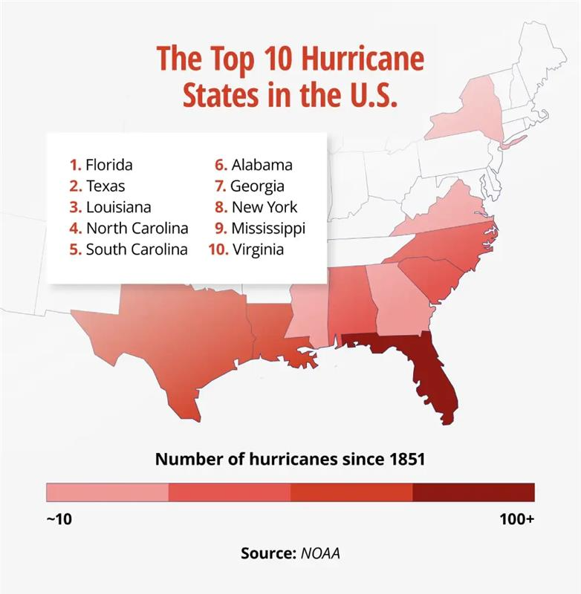
(N.d.). Retrieved from https://fity.club/lists/suggestions/florida-hurricane-history-map/.
Florida experiences high humidity, rainfall, coastal winds and hurricane seasons lasting from June to November due to its subtropical and tropical climate (Wikipedia, 2025). In fact, 83% of category 4 or higher storms in the US have either hit Florida or Texas (Wikipedia, 2025). Hurricane seasons are becoming more active due to the effects of climate change. State planning documents show approximately 15% of the state is at high risk of hurricane force winds causing extensive property damage. There is ample data to show major impacts of highest wind exposure along Florida’s coastline. Surge risk is particularly difficult to model with it is nonlinear rises along with the hurricanes, it remains the largest cause of losses in low lying areas along the coast. It is possible that hurricanes, rainfall and surge can co-occur, amplifying effects and compounding losses. Losses related to extreme weather include damage to structures, outages, flooding, pipe damages, and wind damage to structures.

Coverage Expansion Opportunities
HELP currently insures only commercial properties and limits coverage to physical damage to the property. Florida has distinct insurance policies covering damages from specific natural disasters rather than an insurance option that includes coverage for all natural disasters (Florida Insurance Information Portal, n.d.). Windstorm coverage typically includes physical damage to buildings, contents, detached structures, food spoilage from power outages, and additional living expenses (ALE) during repairs. (Florida Insurance Information Portal, n.d.) The policies do not cover water damage, medical expenses, or vehicle damage as these are covered by separate insurance. (Florida Insurance Information Portal, n.d.) In order for HELP to remain competitive in this market, expanding coverage should be considered after strengthening its core segmentation and pricing capabilities.
Competitors in Florida’s windstorm insurance market include content coverage indicating that, when priced accurately, this segment is profitable. HELP could include content coverage provided as a bundle with the existing coverage for damages to the physical property. As discussed in the data analysis section, contents coverage is a low-risk segment, so HELP will be able to expand its product offerings and attract policyholders without taking on a large amount of risk.
HELP could also consider covering residential properties in addition to their commercial business. Commercial properties tend to involve more risks than personal properties due to higher insured values, complex and varied risks depending on the building type and function, and business interruption exposure. Personal lines offer smaller average claim sizes but have the risk of overwhelming the insurance market when catastrophic events cause damage to a wide area and effect a large number of homes. However, if managed correctly providing coverage for personal properties could provide a good source of diversification for HELP. For example, HELP could consider providing coverage for personal property in lower hazard regions for homes that meet guidelines for protecting their homes again damage. This reduces the loss for these homes, making them desirable for HELPs portfolio.
Another option for expanding coverage is flood insurance. Flooding is the most common and costly natural disaster in the US but is highly underinsured with only 4% of US homeowners having flood insurance (Jencap, 2025). Therefore, there is a large market gap for flood insurance products. In fact, private residential flood policies are expanding at a rate of 20% each year since 2020, showing the potential for profitability in this segment (Jencap, 2025). Although covering floods would significantly increase HELP’s risk exposure, it could remain a profitable with cutting-edge modelling and analytics, support from reinsurers, and lender requirements in high-hazard flood zones (Jencap, 2025).
HELP can also consider geographic expansion across Texas, Georgia, the Carolinas, Virginia, and Tennessee which offer some of the most balanced opportunities for sustainable growth. While Texas and the Carolinas face significant hurricane exposure along the coast (see the figures in the previous section), their inland territories provide profitable, diversified property portfolios with strong population growth (The United States Hurricane Problem, n.d.). These states also experience sufficient convective storm, wind, and secondary-peril activity to support consumer demand for CAT coverage without the extreme volatility found in Florida, Louisiana, or California. Additionally, HELP could consider urban cities like Seattle and Chicago for expansion. In addition to diversifying risk, this allows for expansion into coverage for perils that are not correlated with their current business due to robust modern structures and regions that are less CAT-prone (Yahoo! (n.d.)). When expanding to other US states, HELP should prioritize states with favourable regulatory environments and lower hazard intensities.

Risk Management
Effective risk management is crucial for HELP as it operates exclusively in one of most catastrophe prone regions in the US. The existing regulatory environment around CAT insurance in Florida encourages risk mitigation by offering discounts for properties with protective features. Wind mitigation discounts are available for commercial and personal properties with documented features – like shutters, sloped roofs, and impact resistant doors and windows – that protect against wind and rain damage from hurricanes. There are also discounts for compliance with building code and roof construction (Citizens, n.d.). These kinds of mitigation strategies are beneficial to the insurance landscape because they reduce losses in the event of extreme weather events and make communities more resilient to the effects of changing climates and intensifying natural disasters.
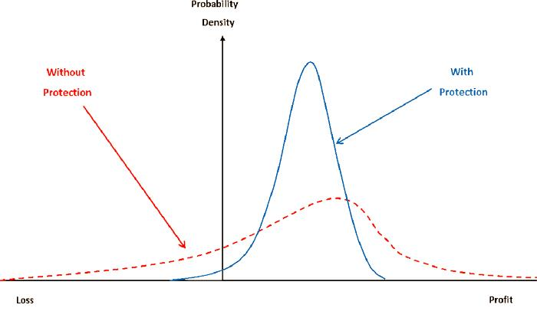
In 2023, bill H.R. 3525 (118th) was proposed for a national catastrophic insurance fund designed to protect insurers in high-risk states like Florida. It would protect insurers in these states from insolvency in the event of covered events of a significant magnitude (govtrack.us., n.d.). It would provide a source of reinsurance to help states manage large-scale losses from natural disasters, aiming to stabilize insurance markets and maintain affordable insurance coverage for policyholders (govtrack.us., n.d.). The bill was rejected but indicates that there may be a need for some similar risk sharing solution to reduce the financial strain on states with high exposure to catastrophic events. Florida’s natural disaster insurance crisis reflects a broader trend of intensifying disasters across the US, indicating that states may not have the ability to recover from major events in the future. There is a need to address climate resilience and mitigation as well as risk sharing mechanisms to ensure sustainability of the CAT insurance markets across the US. HELP can incentivise this on a smaller scale by offering discounts for policyholders that participate in the risk mitigation efforts mentioned previously.
Additionally, HELP can integrate environmental sustainability into its risk management framework by incentivizing climate-resilient and environmentally friendly building practices. Offering premium credits for energy-efficient materials, green roofs, low-carbon construction choices, and storm-resistant upgrades supports both loss reduction and long-term community resilience. These eco-focused mitigation incentives align with ethical considerations around environmental stewardship and reflect HELP’s commitment to supporting sustainable rebuilding in high-risk regions.

Reinsurance Market in Florida
The unique market structure of Florida heavy relies on re-insurers along with its small and mid-sized insurers. There are several active states operated CAT funds like the Florida Hurricane Catastrophe fund (FHCF) and Florida Optional Re-insurance program (FORA) which gives insurers protection at below market rates and serves as a base level protection to fill coverage gaps. Other common re-insurance arrangements are excess-of - loss (XOL) and Quota–Share (QS) which rely on re-insurers covering above certain thresholds and receiving fixed portion of losses and premiums. (Litigation in Florida)
Legislation in Florida has been changed to cater for the high frequency and severity of claims after weather incidents. After hurricane Katrina, there have been stronger requirements for proof and no middle parties involved in claims handling. Further, insurers have been able to make rate adjustments keeping them solvent. With HELP’s size, goals it can operate here but should revise strategy (Litigation in Florida)

Recommendation
To strengthen HELP’s position in Florida’s volatile CAT insurance market, our team recommends a phased strategy that balances immediate operational improvements with long-term resilience.

Short-Term
Over a short-term horizon, HELP should prioritize refining its internal risk segmentation and pricing framework, strengthening its current business. The current framework does not reflect the true drivers of risk, leading to potential underpricing of high-risk exposures and overpricing of low-risk exposures. By adopting a new model for segmentation, HELP can more accurately align premiums with actual risk and understand areas where mitigation efforts can be maximized. This also extends to underwriting and claims handling, where segmentation can ensure proper processing and writing of risk.
HELP can also launch a pilot product for content coverage over the next few years. The pilot will target low-to-moderate risk commercial properties with strong mitigation features. This will allow HELP to expand into content coverage to meet policyholder needs while maintaining a healthy risk exposure while it grows its business. It will also allow HELP to test pricing adequacy, monitor loss experience, and refine underwriting criteria, and understand its risk appetite before increasing the range of content coverage it offers.

Medium Term
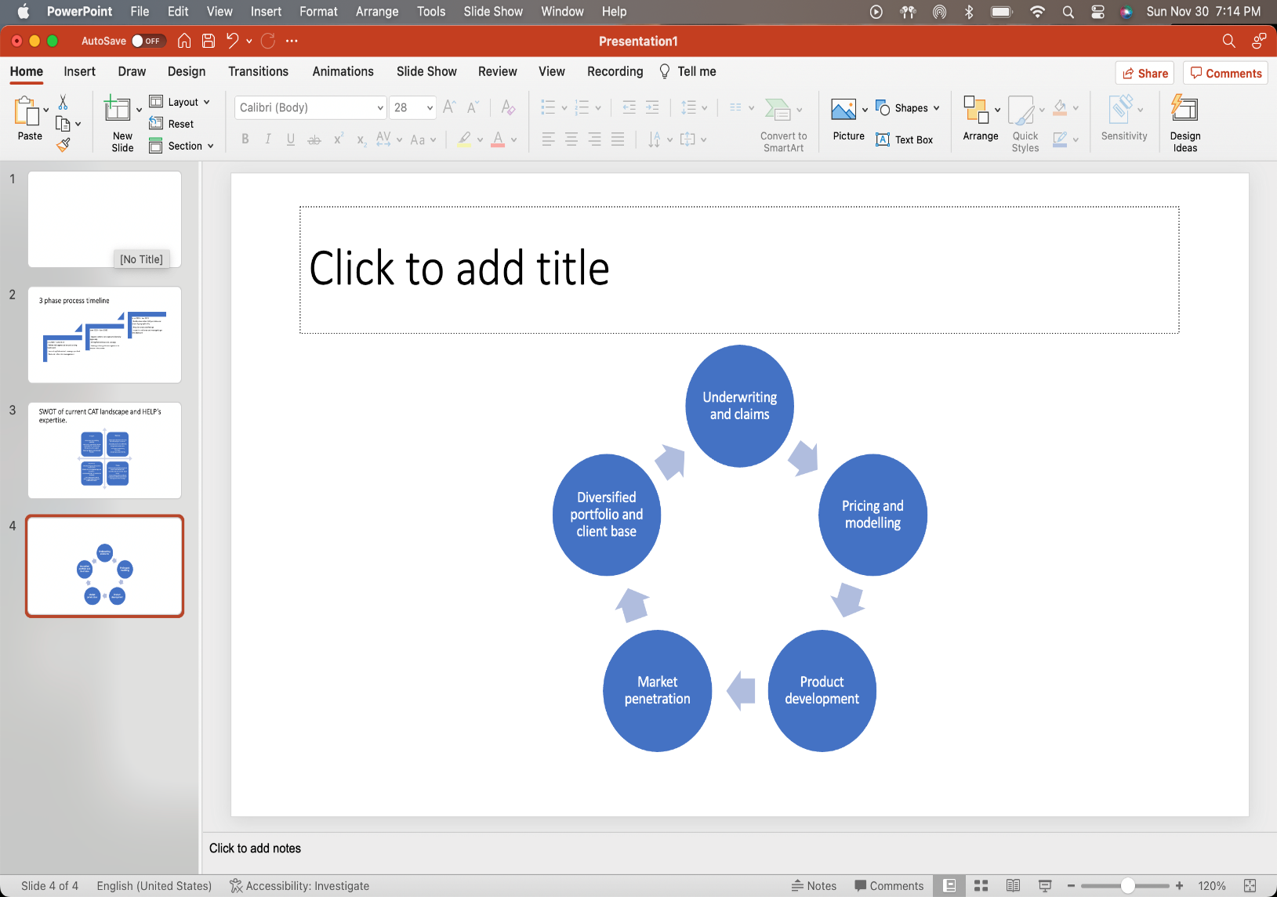
Over the medium term, HELP can expand content coverage to additional segments based on the performance of the pilot in addition to explore regional diversification. Expansion should be approached cautiously, with a focus on inland or lower-hazard regions where CAT exposure is less severe than the current business to avoid correlated losses. Strengthening reinsurance strategy will also be critical to managing volatility as catastrophic events increase in frequency and severity. HELP may consider reinsurance arrangements like quota share or excess-of-loss which offer options for proportional risk transfer or large and infrequent losses, respectively. Structures like this are useful for managing risk in volatile environments and increasing the resilience of the business against extreme losses. Reinsurers favor insurance companies that demonstrate strong risk segmentation and mitigation incentives, which HELP has established in the short-term phase. This will increase the opportunities for affordable and adequate reinsurance.

Long Term
In the long term, HELP should aim to build a diversified CAT portfolio by entering new markets in the US where there are favourable regulatory and reinsurance environments, risks uncorrelated to its current business, and mild risk profile. Now that HELP has established a strong business strategy, reinsurance arrangements, and growth, it can also consider insuring personal property and introducing other CAT coverage like flood insurance. For a small or mid-sized business, the risk of being overwhelmed during catastrophes that result in large losses to many properties is much higher. With HELP’s growth, it is better able to address these challenges which competitors may not be equipped to handle. In terms of geographical expansion, HELP may wish to explore global regions – this is discussed in more detail in the Appendix. HELP should also continue investments into climate resilience strategies to ensure sustainability as the risk landscape evolves.

HELP and Society
Apart from profitability, HELP has a responsibility to sustainably mitigate risk, provide fair pricing, and provide adequate coverage for their insured perils. HELP can meet these responsibilities by offering sound products that meet policyholder needs, managing its risk exposure well, and leveraging internal and external data to create robust models.

References
“The United States Hurricane Problem.” (n.d.). https://www.aoml.noaa.gov/general/graphics/lib/usahp.html?utm_source=chatgpt.com
Bills and resolutions in Congress -- govtrack.us. (n.d.). https://www.govtrack.us/congress/bills/118/hr3525/text/ih
Disaster Insurance in Florida. Florida Insurance Information Portal. (n.d.). https://floridainsurance.org/disaster
Discounts - public - citizens property insurance corporation. Citizens. (n.d.). https://www.citizensfla.com/en/web/public/discounts
https://www.fema.gov/sites/default/files/documents/fema_protect-your-property-storm-surge.pdf
https://www.insurancebusinessmag.com/us/guides/what-is-a-florida-reinsurance-all-about-451039.aspx
Protecting your house from a storm surge – FEMA guidelines
Re-insurance and litigation in Florida – Litigation in Florida
Wikimedia Foundation. (2025, November 28). Florida. Wikipedia. https://en.wikipedia.org/wiki/Florida
Yahoo! (n.d.). 20 US cities least prone to natural disasters - and how much it costs to live in each. Yahoo! Finance. https://finance.yahoo.com/news/20-us-cities-least-prone-130010365.html
The Jencap Personal Lines Insurance Team. (2025, October 27). Flood insurance trends 2026: Private market growth and NFIP shifts. Jencap, Inc. https://jencapgroup.com/insights/personal-lines/flood-insurance-trends-approaching-2026/

Appendix

Global trends
Global catastrophe trends indicate that HELP must adopt a highly disciplined and risk-sensitive approach. According to the Swiss Re Institute, global insured natural catastrophe losses reached USD 137 billion in 2024, driven by weather-related events. There is an upward trajectory in global CAT severity.
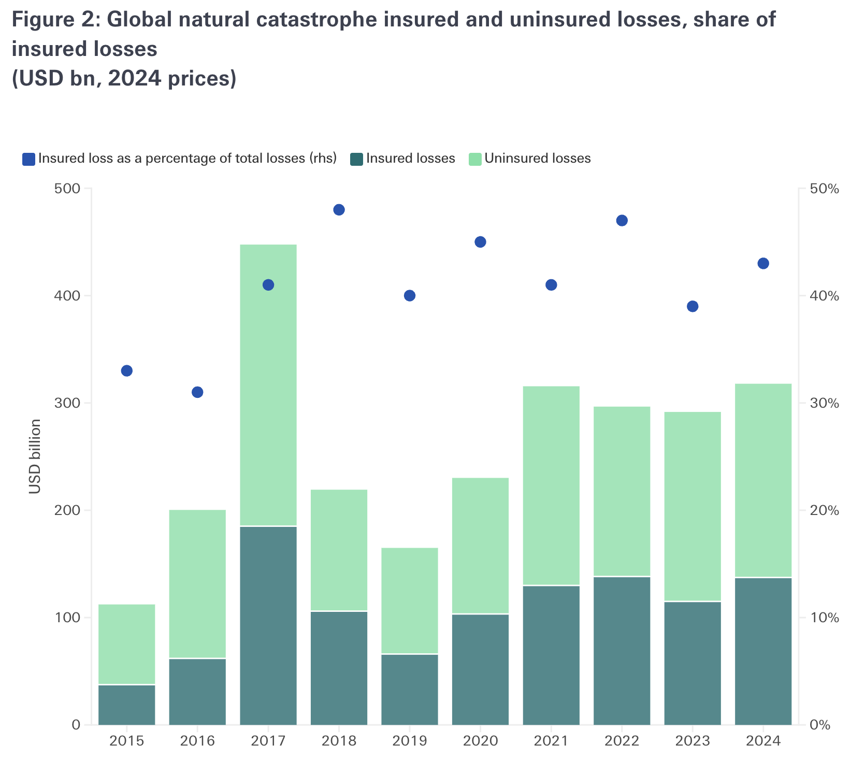
There is a global protection gap, alongside these losses are increasingly driven by secondary perils. Given these conditions, HELP should use a tiered approach and consider penetrating geographic and urban markets.

